Allegory and Artwork in John Marsden and Shaun Tan’s “The Rabbits”
Posted on July 11, 2012 by Myra GB in Asian Literature and Immigrant Experience, Award-Winning, AWB (Award-Winning-Books) 2012, Book Reviews, GB Challenges, GB Reading Themes, Immigrant Stories Challenge 2012, Picture Book Challenge 2012, Picture Books, PoC Reading Challenge 2012, Reading the World 2012 // 13 Comments
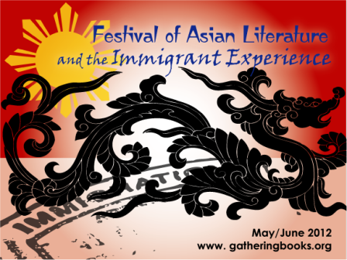
I didn’t realize when we launched our bimonthly theme “Festival of Asian Literature and the Immigrant Experience” – that it would lead me to amazing books such as the one recommended to me by Benjamin Farr from Tanglin Trust School (check out their library here). I thought I have read all of Shaun Tan’s books – apparently I missed out on a few, such as this one.
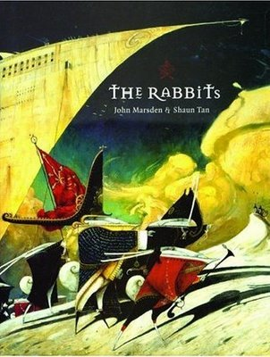
In most of the books that we have read which dealt with the immigrant experience, too often the stories are written from the perspective of the immigrant, the newcomer, the foreigner in the land. The reader is very seldom privy to what goes on in the heads of the ‘natives’.
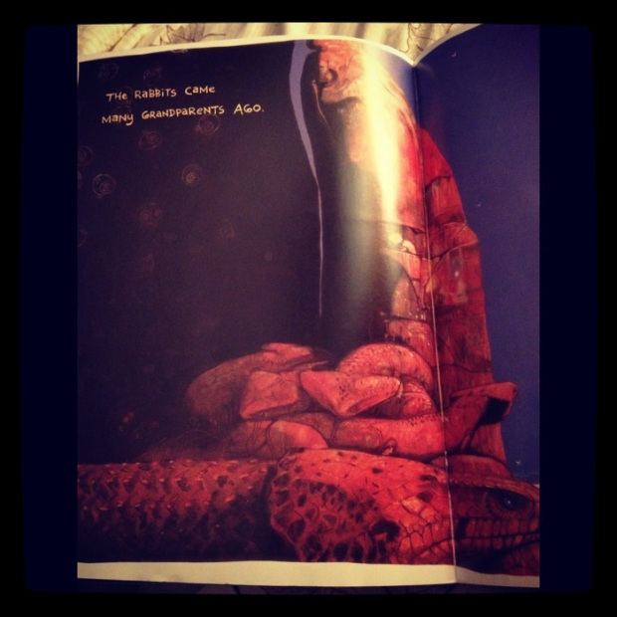
In John Marsden’s The Rabbits one hears the sharp, no-nonsense, powerful voice of the natives (depicted here as numbats) who regard the ‘rabbits’ with a measure of distrust, caution, resentment, defeat, despair, and overwhelming sense of disquiet – all spoken in a matter-of-fact tone that pierces one’s being to the core.
The narrative shows a linear, sequential progression with the rabbits arriving many grandparents ago (as seen in the photo above), and how the “old people warned us: be careful. They won’t understand the right ways” (see photo below) – to the rabbits slowly coming in by water, then through various means – as they bring new food and other animals – and how they spread across the countries – and the fights, oh, the fights which the numbats lost.
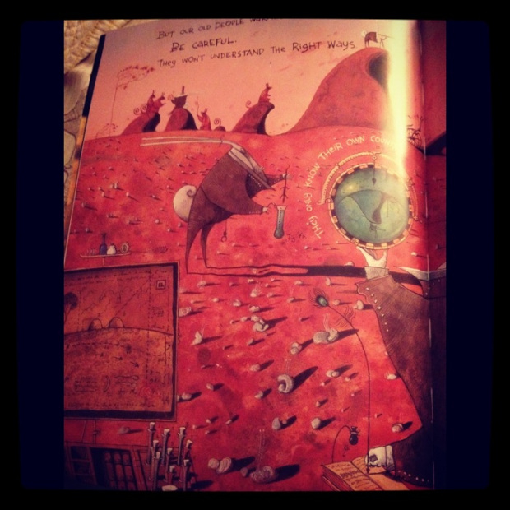
The rabbits after all looked high and mighty with their stiff, starched collars; pointed, upright ears; and their guns, cannons, high-tech weaponry firing in perfect formation – while the numbats carried spears and lived on trees and were subsequently outnumbered and outpowered.
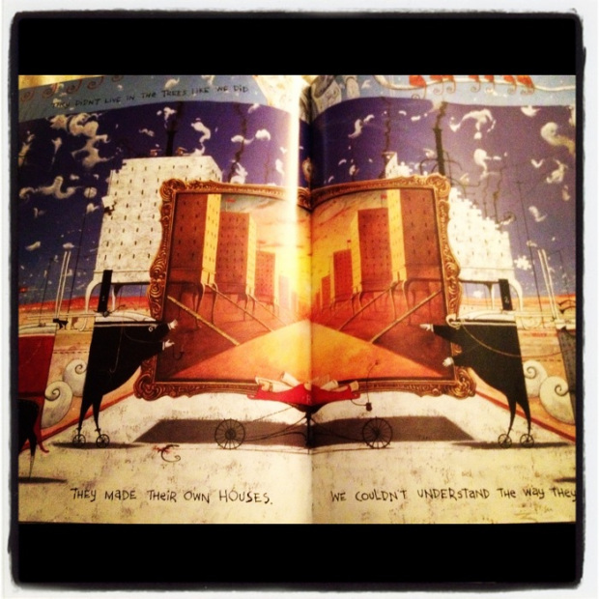
The straightforward, deceptively-simple retelling of Australia’s history is matched perfectly by Shaun Tan’s amazingly-stunning artwork that complements the narrative with dark black spaces, monochrome illustrations of how the rabbits have overtaken the entire country (“Rabbits, rabbits, rabbits. Millions and millions of rabbits. Everywhere we look there are rabbits.”), the sepia-toned undercurrents of loss and tragedy,
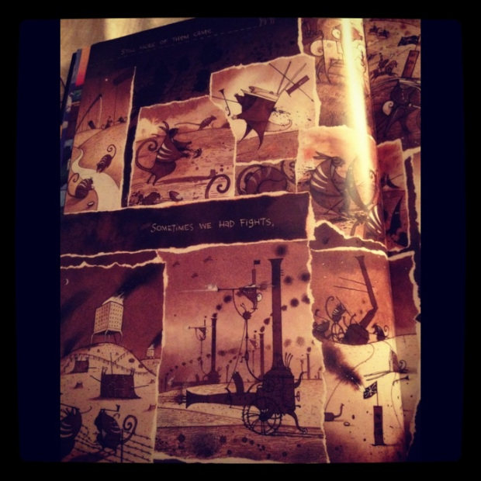
and the deliciously-surreal representation of all that is right and unjust, pure and sullied, and what it means to stand one’s ground (regardless of how shaky and small and crumbling it is). The book is a reminder, as well, of what we value as we cry out in anguish and claim ownership of what is rightfully ours – as one’s entire world is overtaken, captured, and judged to be less than what it is. My heart skipped a million beats when I opened this page that made me gasp out loud:
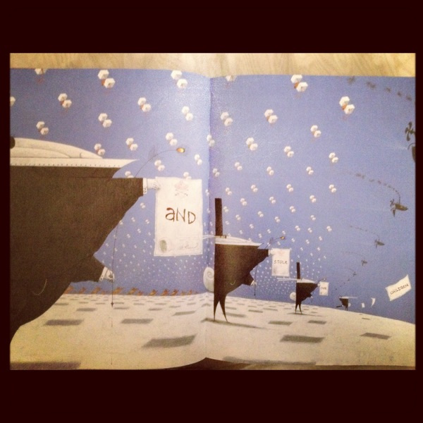
… and stole our children.
I was in Sydney when I watched the film, Australia, with Nicole Kidman and Hugh Jackman, and this clear snow-flurried page with the rabbits holding these signs just broke my heart – as it reminded me vividly of the film and the anguish that I witnessed then.
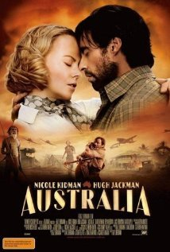
This is one of the most powerful picture books I have read this year. Teachers would have a field day integrating this with their social studies or history class, playing with the metaphors and the allegories, as they struggle to understand history from multiple points of view. For those who want more resources to understand the story line and the allegory better, here is an incisive scholarly piece by Brooke Collins-Gearing & Dianne Osland as published in The Looking Glass: New Perspectives on Children’s Literature.
If you are expecting a neat and fine resolution, with all ends deftly tied – then you’d have to think again. I normally don’t post spoilers here, since I don’t want to ruin the book’s experience for you, but I simply can’t help but quote this plaintive cry found at the end of the book:
Where is the rich, dark earth, brown and moist? Where is the smell of rain dripping from the gum trees?
Where are the great billabongs alive with long-legged birds?
Who will save us from the rabbits?
Here is a video clip from Youtube as inspired by the book. Let me know what you think of it.
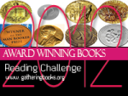Picture Book of the Year – The Children’s Book Council of Australia
AWB Reading Challenge Update: 65 (35)
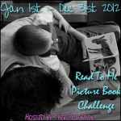
Picture Book Challenge Update: 69 of 120
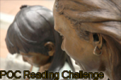
PoC Reading Challenge Update: 26 (25)
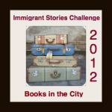
Immigrant Stories Challenge Update: 13 (6)
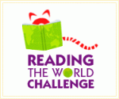
Reading the World Challenge Update: 5 of 7, nonfiction/allegory, Australia
http://gatheringbooks.org/2012/07/11/the-rabbits-by-john-marsden-and-shaun-tan/ - this has the youtube links on it

